The laboratory work 4

Exercise 1: Create a function that can accept two arguments name and age and print its value

Exercise 2: Write a function func1() such that it can accept a variable length of argument and print all arguments value

Exercise 3: Write a function calculation() such that it can accept two variables and calculate the addition and subtraction of them. And also it must return both addition and subtraction in a single return call
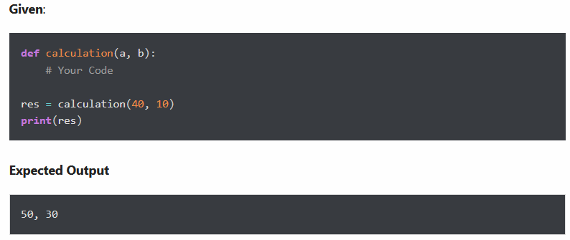

Exercise 4: Create a function showEmployee() in such a way that it should accept employee name, and its salary and display both. If the salary is missing in the function call assign default value 9000 to salary
Given:

Exercise 5: Create an inner function to calculate the addition in the following way
- Create an outer function that will accept two parameters, a and b
- Create an inner function inside an outer function that will calculate the addition of a and b
- At last, an outer function will add 5 into addition and return it

Exercise 6: Write a recursive function to calculate the sum of numbers from 0 to 10
Expected Output:
55

Exercise 7: Assign a different name to function and call it through the new name
Below is the function displayStudent(name, age). Assign a new name showStudent(name, age) to it and call through the new name
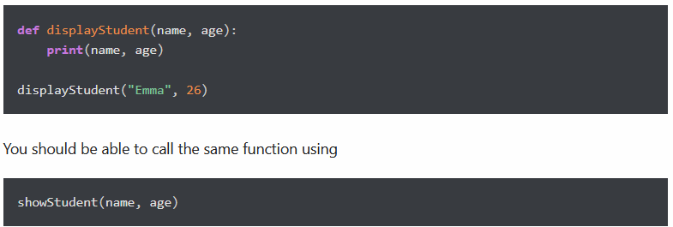

Exercise 8: Generate a Python list of all the even numbers between 4 to 30
Expected Output:

Exercise 9: Return the largest item from the given list

